|  |
| --- |
| UAH Fit Vault Software Requirements Specification |
| CPE 656/658 Software Studio |
| Timothy R. Wilkins  Whit J. Sisulak  Glen L. Riden  James J. Duggan IV |

10/26/2015

# Revision History

|  |  |  |  |
| --- | --- | --- | --- |
| Revision # | Revision Date | Description of Change | Author |
| 0.1 | 9/14/15 | Initial Draft | J. Duggan |
| 0.2 | 9/15/15 | Scope modifications | G. Riden |
| 0.3 | 9/20/15 | Scope update base on requirements review. Added preliminary requirements for data collection.  Added Use case diagrams | J. Duggan  W. Sisulak |
| 0.4 | 9/27/15 | Combined use case diagrams into one diagram. Added use case specifications. Updated requirements | J. Duggan  W. Sisulak  G. Riden |
| 0.5 | 10/11/15 | Changed title. Added revision history table. Added pass/fail conditions to all use case spec post conditions. Added new use case specs. | J. Duggan |
| 0.6 | 10/19/15 | Changed project scope. Updated system requirements. | J. Duggan |
| 0.7 | 10/19/15 | Update project scope. | T. Wilkens |
| 0.8 | 10/20/15 | Updated use case diagram. Removed use cases that are no longer necessary. | W. Sisulak |
| 0.9 | 10/25/15 | Added correct actor names to use cases. Removed and edited use cases. | J. Duggan |

Table Of Contents

Revision History i

Table Of Contents ii

1 Introduction 1

1.1 Purpose 1

1.2 Scope 1

1.3 Definitions, Acronyms, and Abbreviations 2

1.4 References 2

1.5 Overview 2

2 Overall Description 2

2.1 Product Perspective 2

2.2 Product Functions 2

2.3 User Characteristics 2

2.4 Constraints 2

2.5 Assumptions and Dependencies 2

3 Specific Requirements 3

3. Functional Requirements 3

3.2 Non-Functional Requirements 5

Appendix A: Use Case Specifications 6

Requirements Specification

# Introduction

## Purpose

The purpose of this document is to define the software requirements specification for UAH Fit Vault software projects. In addition, this document describes the scope, design constraints, and interfaces of the system. The intended audience for this document includes system developers, testers, customers, and any other stakeholders.

## Scope

The UAH Fit Vault software package will be a web application that will accept medical data from users and display the data in a meaningful way. There are two major components to this software. The first is the data collection tool that is used by the users to upload their medical data that is recorded by one of the supported wearable medical devices. There are three different medical devices supported for this project that record various types of data. The data provided by these devices consists of different file formats, and the data is different from device to device. The software will have to determine the contents of each file and how to process them. Due to how long data transfers take to download the data from a device, there may be a need in the future to convert the data from a binary format to another format in order to speed up the process of getting data off the device. The software needs to able to take in files provided by the medical devices process the files, and store the data in a database. The software should have the ability to process multiple files at a time as well as individual files.

The other major component of the web application is the data analysis tools used to analyze the data that is captured from the data collection tool mentioned above. The software needs to perform data analysis over different intervals of time such as one week, one month, etc. There will need to be some way to manage user access to the various medical data that has been inserted into the database that this software will access. Below are some proposed data analysis ideas that can be incorporated into the project.

* Simple Moving Average
* Data correlation discovery between the multiple devices.
* Possibly determine when an individual moves from walking to running or simply being able to identify the activities that were being performed while the data was being captured.

The data analysis possibilities will likely not fully be realized until the project team understands the different types of data that are available. Also, there will need to be collaboration with the customer for additions or changes to the data measurements provided by this software. The web application will have to have different levels of user access which will be defined later in this document.

## Definitions, Acronyms, and Abbreviations

## References

* IEEE Recommended Practice for Software Requirements Specifications (IEEE Std 830-1998)
* Microsoft Secure Passwords (https://www.microsoft.com/security/pc-security/password-checker.aspx)

## Overview

The remainder of this requirements specification document addresses specific system requirements, constraints, and design specifications, as well as process plans and methods for the requirements specifications team.

# Overall Description



## Product Perspective

## Product Functions

## User Characteristics

## Constraints

## Assumptions and Dependencies

# Specific Requirements



## Functional Requirements

### The system shall provide user authentication.

#### The users shall belong to one of the following roles.

##### Patient

###### The system shall prevent any personal identifiable information from being available for a Patient

###### The system shall only allow a Patient to view their data.

##### Physician

###### The system shall only allow Physicians to view the data associated with their patients.

##### Experiment Administrator

##### System Administrator

###### System Administrators will have the ability to enable, disable, add, and remove all users.

###### System administrators will have the ability to associate and disassociate a patient and a physician.

###### System administrators will have the ability to reset passwords.

###### System administrators will be able to update physician, patient and experiment administrator account information.

###### System administrators shall not be allowed to view patient health data.

#### The system shall require unique usernames for each registered user.

##### Usernames will be changed as long as the username remains unique.

#### The system shall assign unique ids to each created patient.

##### The system shall display the patient id to the user that created the patients so that the user can keep a record of which patient corresponds to which id.

#### The system shall require a secure password.

#### The system shall have the ability to log out of a user’s account.

#### The system will have a utility for retrieving a forgotten username or password.

#### The system shall allow Physicians and Experiment Administrators to create their own accounts.

##### The system shall require a system administrator to verify the creation of a new Physician or Experiment Administrator.

##### Physicians and Experiment Administrator shall create the accounts of their patients.

### The system shall provide the ability to process medical device data files.

#### The he system shall process multiple files at the same time or a single file.

#### The system shall process multiple files at the same time or a single file.

#### The system shall give the user an interface to select which files to process.

#### The system shall not process data that is not medical data.

#### The system shall process .csv files for each of the supported devices.

#### The system will process .dat files for each of the supported devices.

### The system shall support the following wearable medical devices.

#### Zephyr

#### BasisPeak

#### Microsoft Band.

### The system shall connect to a database.

#### The system shall upload the processed data to the database.

## Non-Functional Requirements

### The system shall run on Windows Server Operating System

### The system shall use a SQL database.

### The system shall require a server to be connected to a reliable network with an internet connection.

Appendices

# Appendix A: Use Case Specifications

This section represents the use case specifications for the functions defined in the requirements specification for the two pieces of software needed to complete this project.

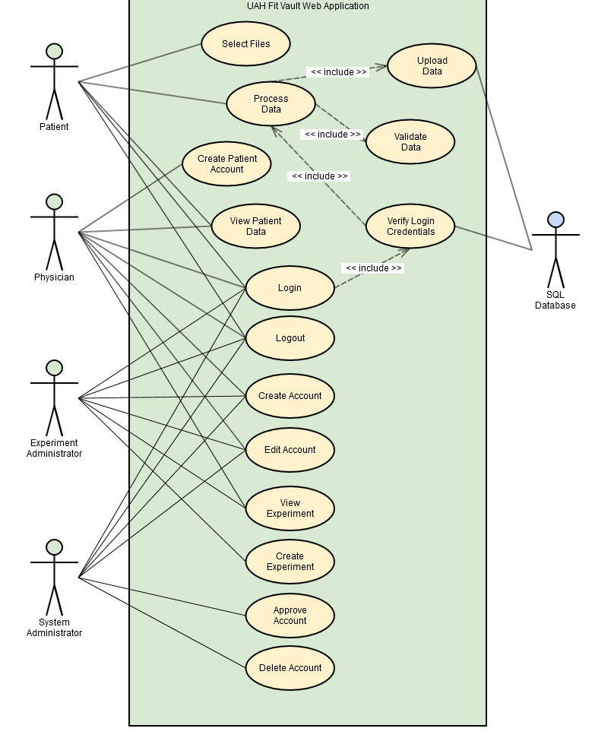

Figure A-1: Use Case Diagram

|  |  |  |
| --- | --- | --- |
| Use Case ID | UC_001 | |
| Use Case Name | Select Data Files | |
| Actor(s) | Patient | |
| Purpose | Select the data file or files to be processed and uploaded to the database. | |
| Overview | The patient needs a way to select files to be uploaded | |
| Cross-References | *<requirements to be inserted here after finalized>* | |
| Pre-conditions | The patient has access to the software and is authenticated. The user has the appropriate permissions for importing data. | |
| Post-conditions | **PASS:** The files have been selected for processing.  **FAIL:** No files are available for processing. | |
| Course of Events | | |
| Actor Actions | | **System Response** |
| 1. Patient navigates to the directory of files they wish to process | |  |
| 2. Patient selects all files they wish to upload. | |  |
|  | | 2. The system loads the files. |

|  |  |  |
| --- | --- | --- |
| Use Case ID | UC_002 | |
| Use Case Name | Process Data | |
| Actor(s) | Patient | |
| Purpose | Patient initiates file processing | |
| Overview | The patient initiates the action to process the loaded files | |
| Cross-References | *<requirements to be inserted here after finalized>* | |
| Pre-conditions | The files have been selected via UC_001 or UC_002. The user has been authenticated and has the appropriate permissions. | |
| Post-conditions | **PASS:** The files are ready to be uploaded in to the database.  **FAIL:** The files will not be uploaded to the database. | |
| Course of Events | | |
| Actor Actions | | **System Response** |
| 1. Patient initiates the file processing action. | |  |
|  | | 2. The system processes the files. |

|  |  |  |
| --- | --- | --- |
| Use Case ID | UC_003 | |
| Use Case Name | Validate Data | |
| Actor(s) | System | |
| Purpose | Validate processed data | |
| Overview | The system validates the data being processed based on the device and medical data type. | |
| Cross-References | *<requirements to be inserted here after finalized>* | |
| Pre-conditions | The files have been loaded via use case #1 or #2 and the processing step has been initiated. The user has been authenticated and has the appropriate permissions. | |
| Post-conditions | **PASS:** The files are determined to be valid or invalid.  **FAIL:** System error message displayed to the user informing that the files could not be processed. | |
| Course of Events | | |
| Actor Actions | | **System Response** |
| 1. The process data use case initiates the validation of the files. | |  |
|  | | 2. The system validates the files. |

|  |  |  |
| --- | --- | --- |
| Use Case ID | UC_004 | |
| Use Case Name | Upload Data | |
| Actor(s) | System | |
| Purpose | Upload data into the database | |
| Overview | The software uploads the validated data into the SQL database. | |
| Cross-References | *<requirements to be inserted here after finalized>* | |
| Pre-conditions | The data has been validated and is ready for the upload and the database is online. The user has been authenticated and has the appropriate permissions. | |
| Post-conditions | **PASS:** The data is uploaded into the database.  **FAIL:**  An error message is displayed informing the user the upload failed. | |
| Course of Events | | |
| Actor Actions | | **System Response** |
| 1. The process data use case initiates the upload of the data | |  |
|  | | 2. The system uploads the data into the SQL database. |

|  |  |
| --- | --- |
| Use Case ID | UC_005 |
| Use Case Name | Login Data Collection Software |
| Actor(s) | Patient, Physician, Experiment Administrator, System Administrator |
| Purpose | Procedure for logging into the data collection software. |
| Overview | The user needs to be able to login to the data collection software in order for the software to know who is uploading data to the database. |
| Cross-References | *<requirements to be inserted here after finalized>* |
| Pre-conditions | The system has the data collection software installed on it.  The user must have created an account on the web site.  The user has launched the data collection tool and it is currently running. |
| Post-conditions | **PASS:** The data collection software is ready to upload data to the database.  **FAIL:** The user is prompted again to enter their username and password. The user will not be allowed to upload data until their credentials are validated. |
| Course of Events | |
| Actor Actions | **System Response** |
| 1. User selects data to upload and submits the data to upload. |  |
|  | 2. The software issues a modal dialog prompting the user to login to the system. |
| 3. The user enters their username and password into the corresponding fields on the modal dialog. |  |
|  | 4. The software verifies the user’s credentials and logs the user into the system. |

|  |  |
| --- | --- |
| Use Case ID | UC_006 |
| Use Case Name | Logout Data Collection Software |
| Actor(s) | Patient, Physician, Experiment Administrator, System Administrator |
| Purpose | Procedure for logging out of the data collection software. |
| Overview | From a security stand point the user shall have the ability to log them out of the data collection tool so data to prevent unauthorized data entry if a computer is shared with another user. |
| Cross-References | *<requirements to be inserted here after finalized>* |
| Pre-conditions | The system has the data collection software installed on it.  The user must have created an account on the web site.  The user has launched the data collection tool and it is currently running.  The user is currently logged into the system. |
| Post-conditions | **PASS:** The user can no longer upload data.  **FAIL:** The user remains logged into the system. |
| Course of Events | |
| Actor Actions | **System Response** |
| 1. User selects the logout action. |  |
|  | 2. The software deletes the user’s login credentials from the application session. |

|  |  |
| --- | --- |
| Use Case ID | UC_007 |
| Use Case Name | Verify Login Credentials |
| Actor(s) | Patient, Physician, Experiment Administrator, System Administrator |
| Purpose | Procedure for verifying the login credentials of a user. |
| Overview | The username and password entered by the user must be validated prior to granting the user a successful login into the system to upload data. |
| Cross-References | *<requirements to be inserted here after finalized>* |
| Pre-conditions | The system has the data collection software installed on it.  The user must have created an account on the web site.  The user has launched the data collection tool and it is currently running. |
| Post-conditions | **PASS:** The user has been logged into the system.  **FAIL:** The user remains logged out of the system and an error message is present to the user informing that there was an invalid username or password entered. |
| Course of Events | |
| Actor Actions | **System Response** |
| 1. User enters username and password into the login modal dialog. |  |
|  | 2. The software queries the account table in database to authenticate the user. |